Boundary
# Source: AI Source: Provided by: [Data Path: Persons Table -> ID Column: 1, Name_En Column: Motasem Essam] -> From: [ChatGPT] on [7/25/2026]
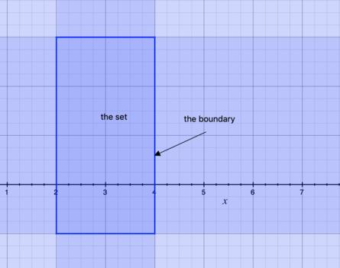
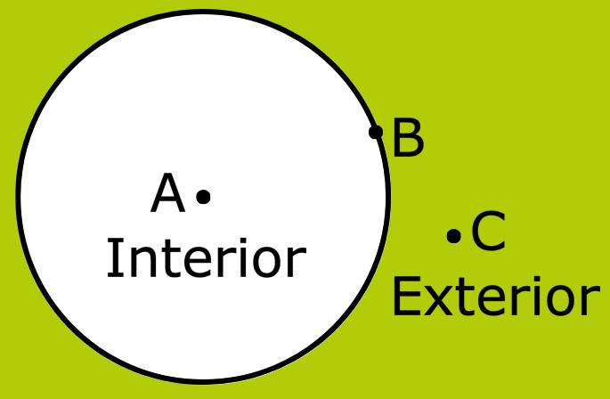
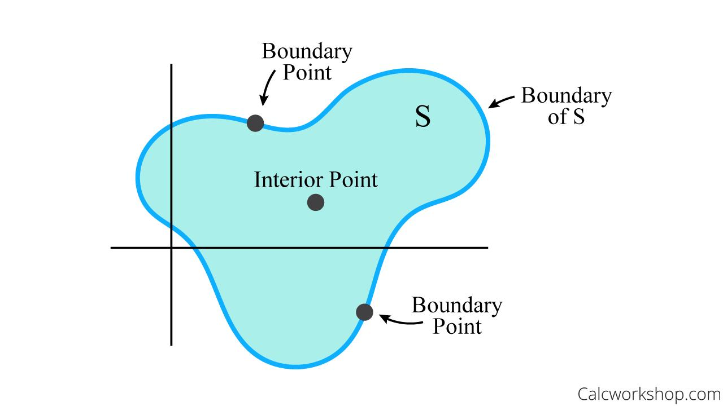
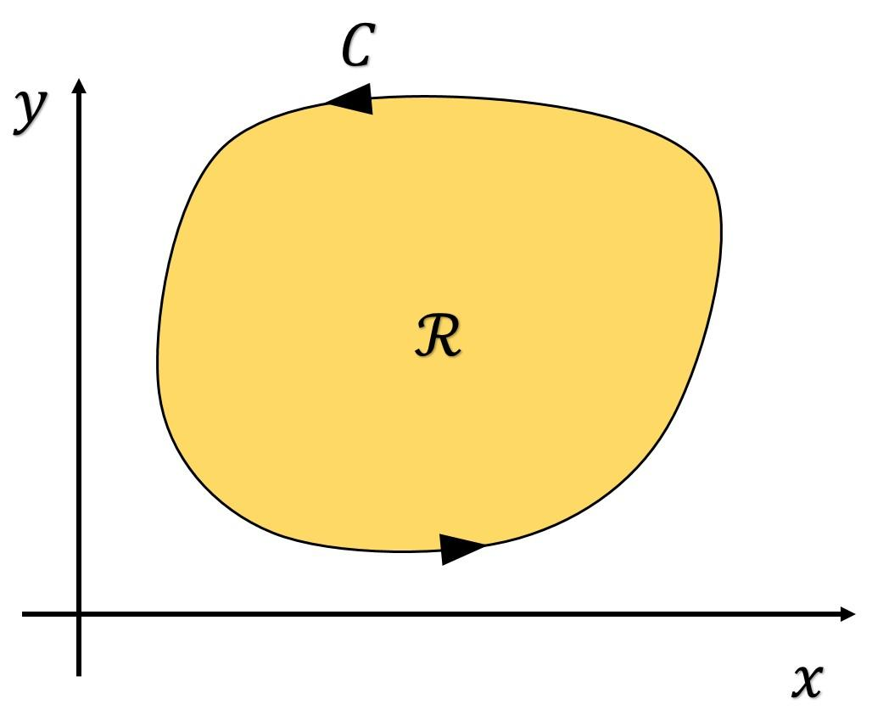
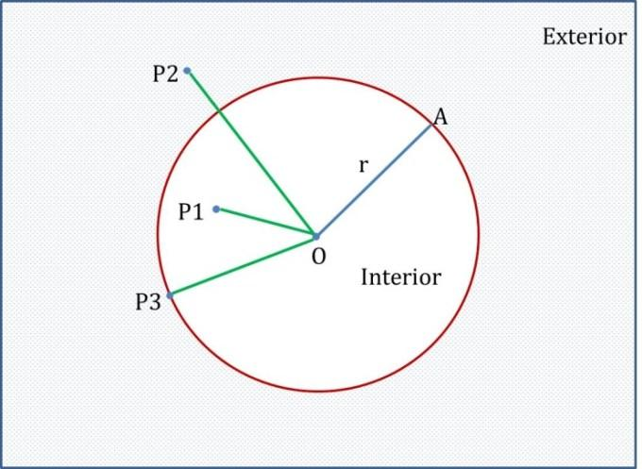

Definition
# Source: AI Source: Provided by: [Data Path: Persons Table -> ID Column: 1, Name_En Column: Motasem Essam] -> From: [ChatGPT] on [7/25/2026]
A Boundary is the set of points that separates a geometric region from the surrounding space. It forms the edge or limit of a region but is not part of its interior unless specifically included by definition.
In plane geometry, a boundary is typically made up of one or more geometric objects such as:
- Line segments
- Rays
- Lines
- Curves
- Circles
- Polygon edges
A boundary determines where a region begins and ends.

Characteristics
# Source: AI Source: Provided by: [Data Path: Persons Table -> ID Column: 1, Name_En Column: Motasem Essam] -> From: [ChatGPT] on [7/25/2026]
A boundary:
- Separates the interior from the exterior of a region.
- Has no thickness.
- May consist of straight or curved geometric objects.
- May be open or closed.
- Can enclose a bounded region.
- Contains infinitely many points.

Illustration

Boundary of a Rectangle
# Source: AI Source: Provided by: [Data Path: Persons Table -> ID Column: 1, Name_En Column: Motasem Essam] -> From: [ChatGPT] on [7/25/2026]
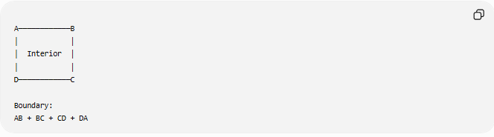
A────────────B
│ │
│ Interior │
│ │
D────────────C

Boundary:
AB + BC + CD + DA
The four edges form the boundary.

Boundary of a Circle
# Source: AI Source: Provided by: [Data Path: Persons Table -> ID Column: 1, Name_En Column: Motasem Essam] -> From: [ChatGPT] on [7/25/2026]
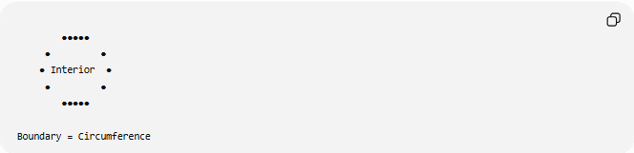
●●●●●
● ●
● Interior ●
● ●
●●●●●

Boundary = Circumference
The circumference is the boundary of the circular region.

Mathematical Representation
# Source: AI Source: Provided by: [Data Path: Persons Table -> ID Column: 1, Name_En Column: Motasem Essam] -> From: [ChatGPT] on [7/25/2026]
Suppose:
$$R$$
is a region.
Its boundary is denoted by:
$$∂R$$
(read as "the boundary of $R$").

Example
Interior of a circle:
$$x^{2}+y^{2}<r^{2}$$
Boundary:
$$x^{2}+y^{2}=r^{2}$$

Boundary vs Interior
# Source: AI Source: Provided by: [Data Path: Persons Table -> ID Column: 1, Name_En Column: Motasem Essam] -> From: [ChatGPT] on [7/25/2026]
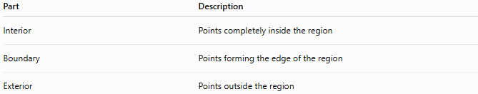
Part | Description
Interior | Points completely inside the region
Boundary | Points forming the edge of the region
Exterior | Points outside the region

Examples
# Source: AI Source: Provided by: [Data Path: Persons Table -> ID Column: 1, Name_En Column: Motasem Essam] -> From: [ChatGPT] on [7/25/2026]
Example 1
For a square:
Boundary:
- Four line segments.
Interior:
- All points enclosed by the four sides.

Example 2
For a triangle:
Boundary:
- Three line segments.
Interior:
- The enclosed triangular region.

Example 3
For a circle:
Boundary:
- The circumference.
Interior:
- All points inside the circumference.

Types of Boundaries

Closed Boundary
# Source: AI Source: Provided by: [Data Path: Persons Table -> ID Column: 1, Name_En Column: Motasem Essam] -> From: [ChatGPT] on [7/25/2026]
Forms a complete enclosure.
Examples:
- Circle
- Triangle
- Rectangle
- Polygon
These boundaries create bounded regions.

Open Boundary
# Source: AI Source: Provided by: [Data Path: Persons Table -> ID Column: 1, Name_En Column: Motasem Essam] -> From: [ChatGPT] on [7/25/2026]
Does not completely enclose a region.
Examples:
- Line segment
- Ray
- Open curve

Straight Boundary
# Source: AI Source: Provided by: [Data Path: Persons Table -> ID Column: 1, Name_En Column: Motasem Essam] -> From: [ChatGPT] on [7/25/2026]
Constructed from straight line segments.
Examples:
- Rectangle
- Square
- Triangle

Curved Boundary
# Source: AI Source: Provided by: [Data Path: Persons Table -> ID Column: 1, Name_En Column: Motasem Essam] -> From: [ChatGPT] on [7/25/2026]
Constructed from curves.
Examples:
- Circle
- Ellipse
- Arc

Boundary in Coordinate Geometry
# Source: AI Source: Provided by: [Data Path: Persons Table -> ID Column: 1, Name_En Column: Motasem Essam] -> From: [ChatGPT] on [7/25/2026]
Example:
Rectangle:
$$0≤x≤5, 0≤y≤3$$
Boundary consists of:
$$x=0 \\ x=5 \\ y=0 \\ y=3$$

Real-World Examples
# Source: AI Source: Provided by: [Data Path: Persons Table -> ID Column: 1, Name_En Column: Motasem Essam] -> From: [ChatGPT] on [7/25/2026]
Boundaries appear in:
- Property lines.
- Country borders.
- Room walls.
- Garden fences.
- Stadium outlines.
- Computer graphics.
- Maps.
- Parking spaces.

Applications
# Source: AI Source: Provided by: [Data Path: Persons Table -> ID Column: 1, Name_En Column: Motasem Essam] -> From: [ChatGPT] on [7/25/2026]
Boundaries are used in:
- Plane Geometry
- Coordinate Geometry
- Analytic Geometry
- Topology
- GIS (Geographic Information Systems)
- Computer Graphics
- CAD (Computer-Aided Design)
- Engineering
- Architecture
- Surveying

Advantages
# Source: AI Source: Provided by: [Data Path: Persons Table -> ID Column: 1, Name_En Column: Motasem Essam] -> From: [ChatGPT] on [7/25/2026]
Studying boundaries helps to:
- Define geometric regions.
- Compute perimeter.
- Separate interior and exterior.
- Analyze geometric figures.
- Solve optimization problems.

Limitations
# Source: AI Source: Provided by: [Data Path: Persons Table -> ID Column: 1, Name_En Column: Motasem Essam] -> From: [ChatGPT] on [7/25/2026]
A boundary:
- Has no area.
- Has no thickness.
- Does not necessarily belong to the interior.
- May become complex for irregular shapes.

Comparison with Related Concepts
# Source: AI Source: Provided by: [Data Path: Persons Table -> ID Column: 1, Name_En Column: Motasem Essam] -> From: [ChatGPT] on [7/25/2026]
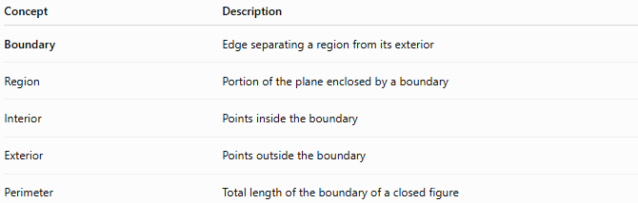
Concept | Description
Boundary | Edge separating a region from its exterior
Region | Portion of the plane enclosed by a boundary
Interior | Points inside the boundary
Exterior | Points outside the boundary
Perimeter | Total length of the boundary of a closed figure

Key Points
# Source: AI Source: Provided by: [Data Path: Persons Table -> ID Column: 1, Name_En Column: Motasem Essam] -> From: [ChatGPT] on [7/25/2026]
- A Boundary separates a region from the surrounding plane.
- It consists of geometric objects such as:
  - Line segments
  - Curves
  - Circles
- Mathematical notation:
$$∂R$$
- Closed boundaries enclose regions.
- Boundaries have length but no area.

Conclusion
# Source: AI Source: Provided by: [Data Path: Persons Table -> ID Column: 1, Name_En Column: Motasem Essam] -> From: [ChatGPT] on [7/25/2026]
A Boundary is the geometric edge that separates a region from the surrounding plane. It consists of the points forming the limit of a figure and plays a fundamental role in defining interiors and exteriors. Boundaries are essential in plane geometry, coordinate geometry, analytic geometry, topology, engineering, architecture, surveying, GIS, CAD, and computer graphics, where they are used to define shapes, compute perimeters, model enclosed spaces, and analyze spatial relationships.

